Support the MFA by entering Give the Arts a Chance 2016, a sweepstakes that benefits programs at the Museum of Fine Arts, Boston.
Entries must be received by May 2, 2016. Questions? Call 617-369-3169.
Prizes
- Viking River Cruise for Two from Amsterdam to Budapest ..,
- Exclusive Patron Membership at the MFA ..,

- Boston Dining and Theater, plus a Duxbury Getaway ..,

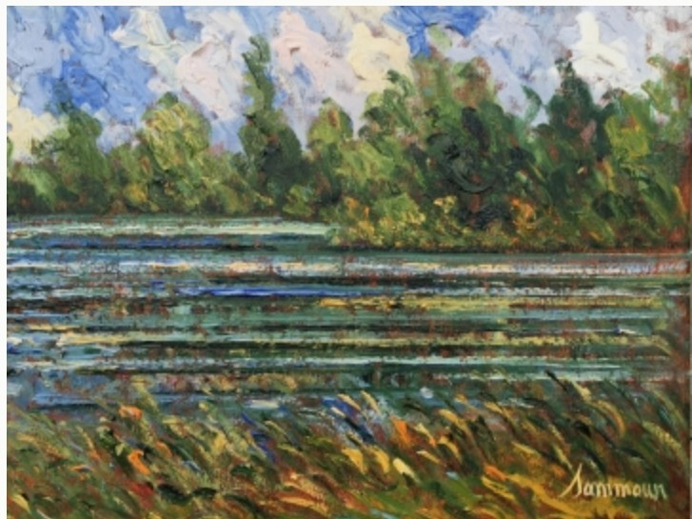
- Contemporary Impressionistic Painting ....
Invitation to Fishing II is by the Canadian artist Samir Sammoun and was donated by Newbury Street's Galerie d'Orsay. The painting's richly colored palette alludes to the Mediterranean landscapes of Sammoun's Lebanese childhood. Oil on canvas. 16 x 20 inches.
Estimated Value: $4,950

- Al Fresco Dining Set

- Porcelain Vase, Gold Glaze with "Snow Cap" Prize Sponsors

Support Our Cause
Open Houses at the MFA welcome our neighbors and visitors from near and far to enjoy a free day of arts and cultural programming. Open House programming includes art making, music, dance, performance art, tours, and much more. Last year, more than 30,000 visitors enjoyed our encyclopedic collection and took advantage of free admission on these days. A portion of the donations received will continue to support existing open houses.

